Dealing with the Inventory Risk

A solution to the market making problem

Olivier Gu´eant · Charles-Albert Lehalle · Joaquin Fernandez-Tapia

**2 Setup of the model**

dSt = σdWt

qt = Ntb – Nt

**3 Characterization of the optimal quote**

Proposition 1 (Change of variables for (HJB))

Proposition 2 (Solution of the ordinary differential equations)

Theorem 1 (Solution of the control problem)

**4 Asymptotic behavior and approximation of the optimal quotes**

Theorem 2 (Asymptotics for the optimal quotes)

Proposition 3

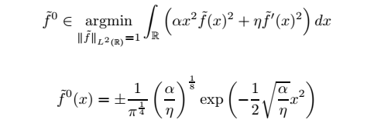

**5 Extensions of the model**

Proposition 4 (Solution with a drift)

dSt = µdt + σdWt

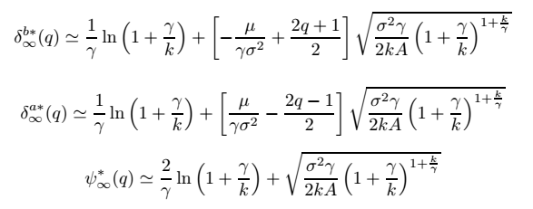

Proposition 5 (Solution with market impact)

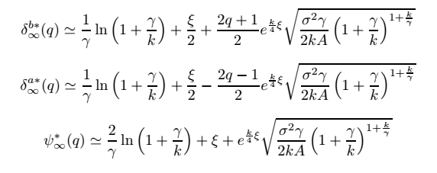

7 Backtests

